Project Files

Date | 19 December 2025
Team ID
Project Name | workforce administration solution (dev)
Maximum Marks

In a Salesforce-based development project, "executable files" refer to the metadata components, configurations, and custom code (Apex, LWC, Flows, etc.) that make up the deployable and runnable solution within the Salesforce ecosystem. These components collectively form the Workforce Administration Solution and are stored as project files in a Salesforce DX (SFDX) structure.

A.Custom Salesforce object:
We have created employee object with the formate

1.Record Name : Employee ID 2.Data Type : Auto Number
3.Display Format : EMS-{0000} 4.Starting Number : 1
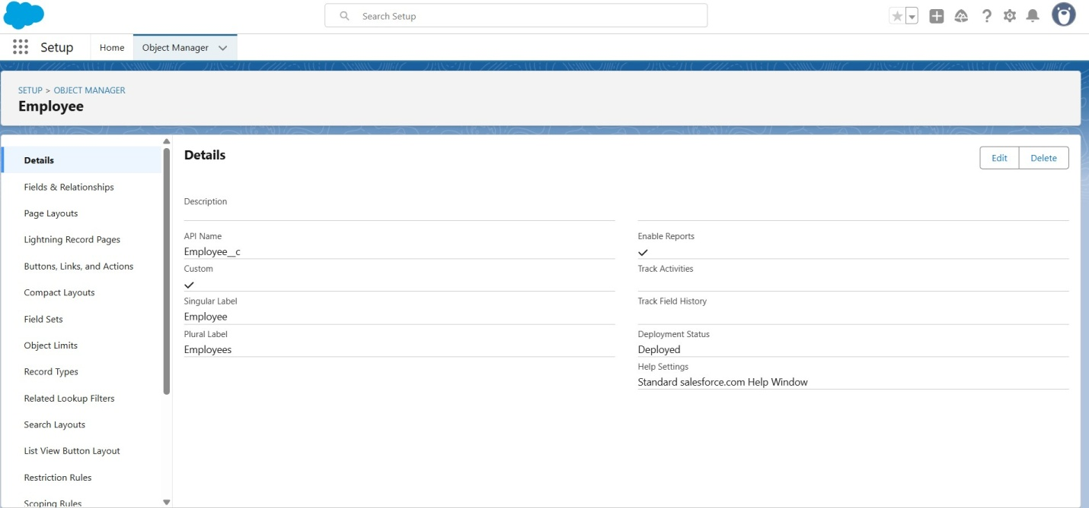

Similarly: ProjectTask, Asset, Asset Service

- Project Task :

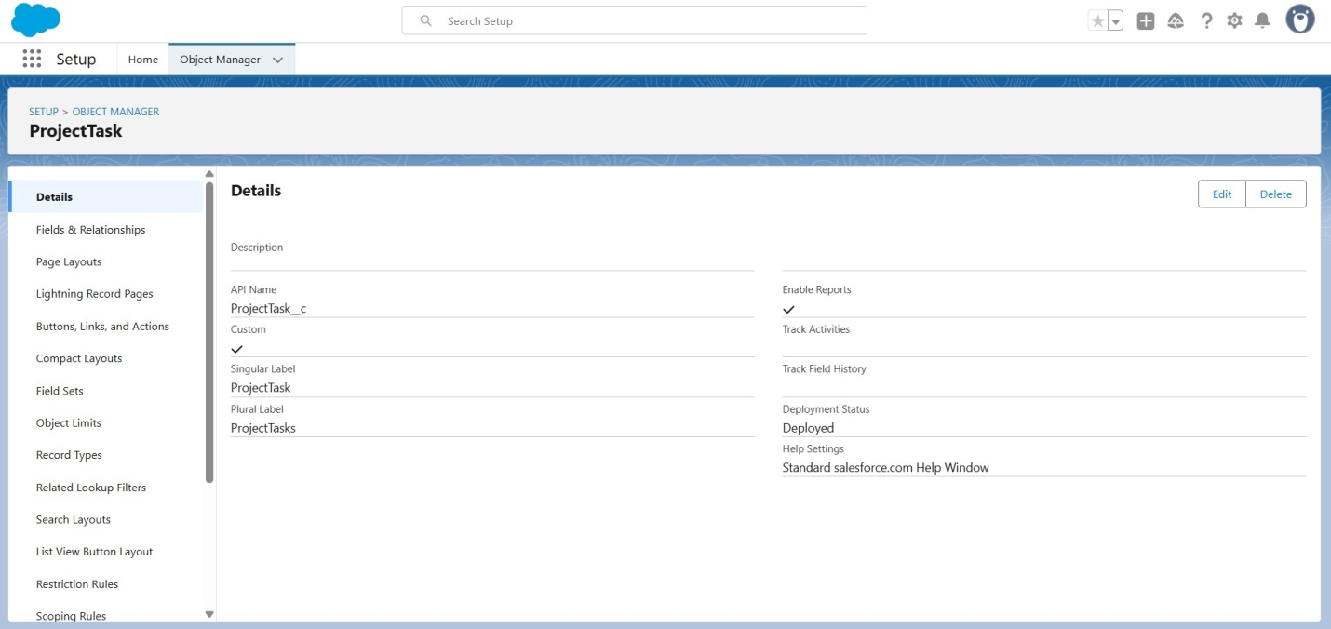

- Asset:

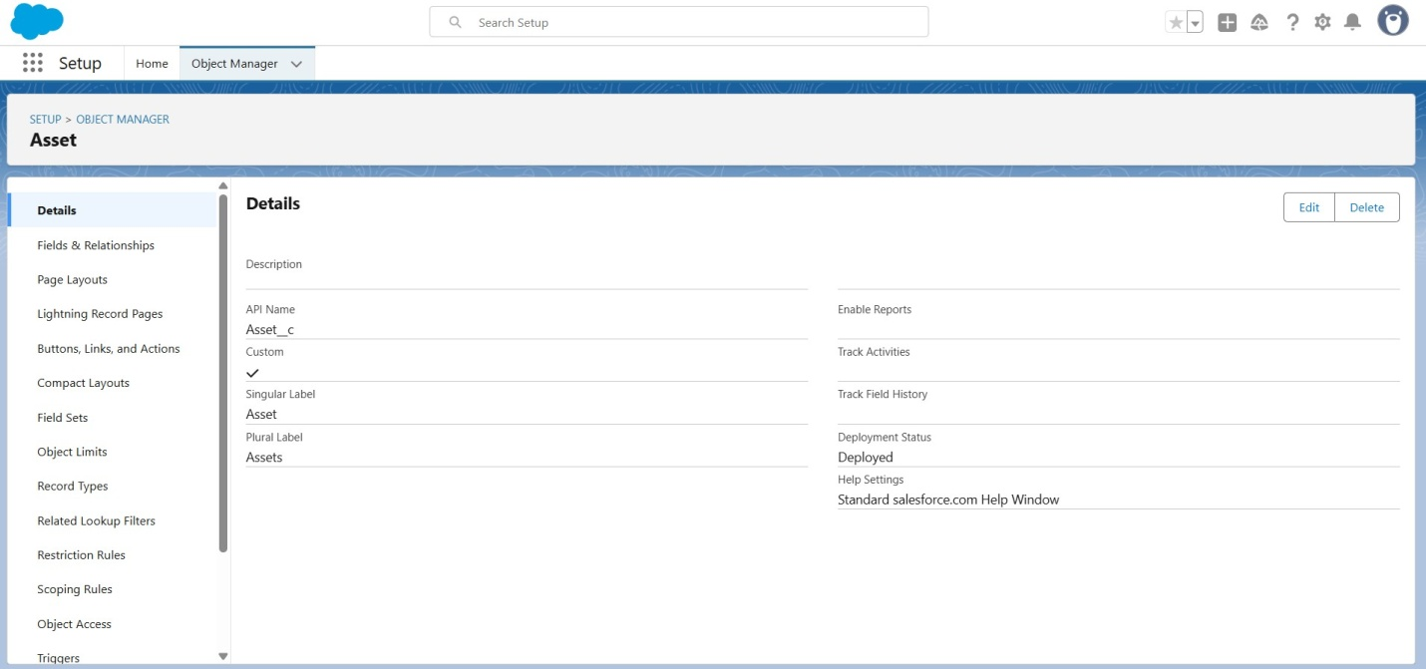

- Asset Service :

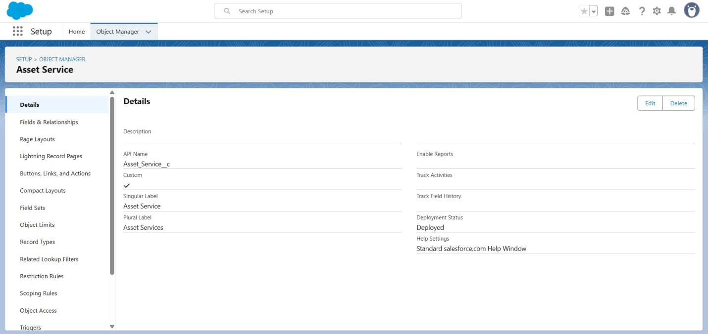

B.CustomTabs and App

- Tabs for each object

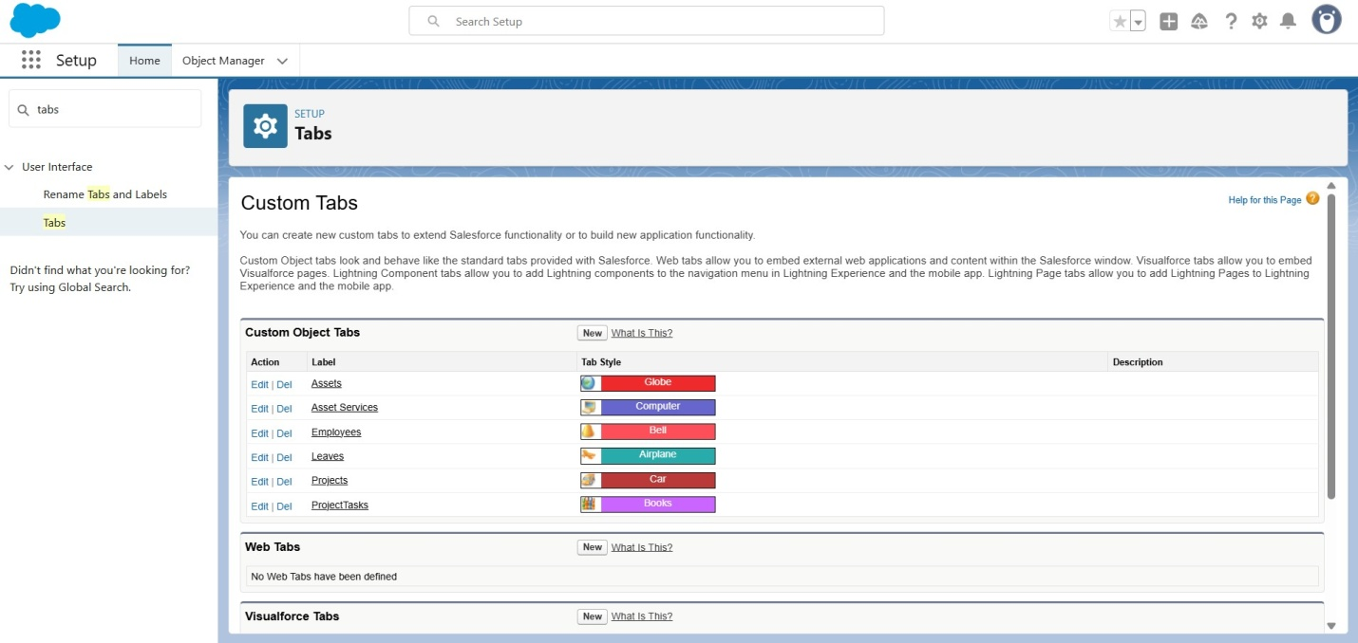
- Fields and relationships:

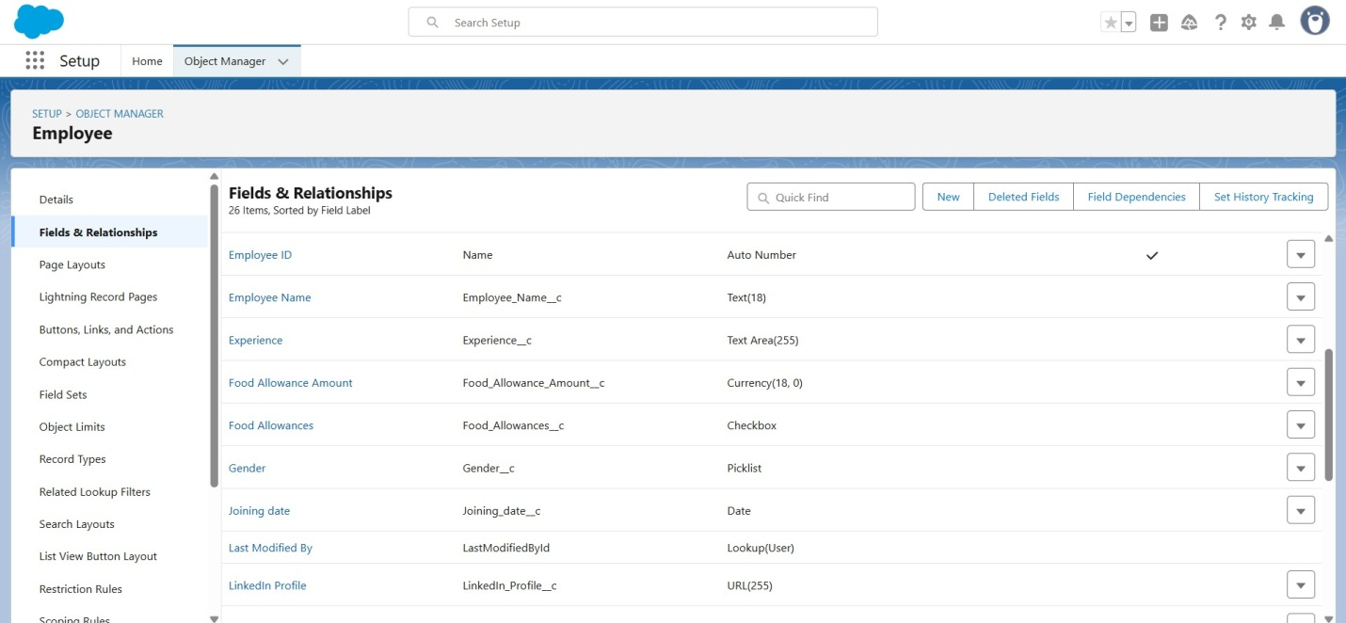

As we can see employee name field in employee object similarly for ProjectTask,
Asset, Asset Service- objects

- Import Data :

With given URL link of CSV file https://tinyurl.com/SF-Employee-Data

Verified that your data has been imported under batches.

E.Roles:

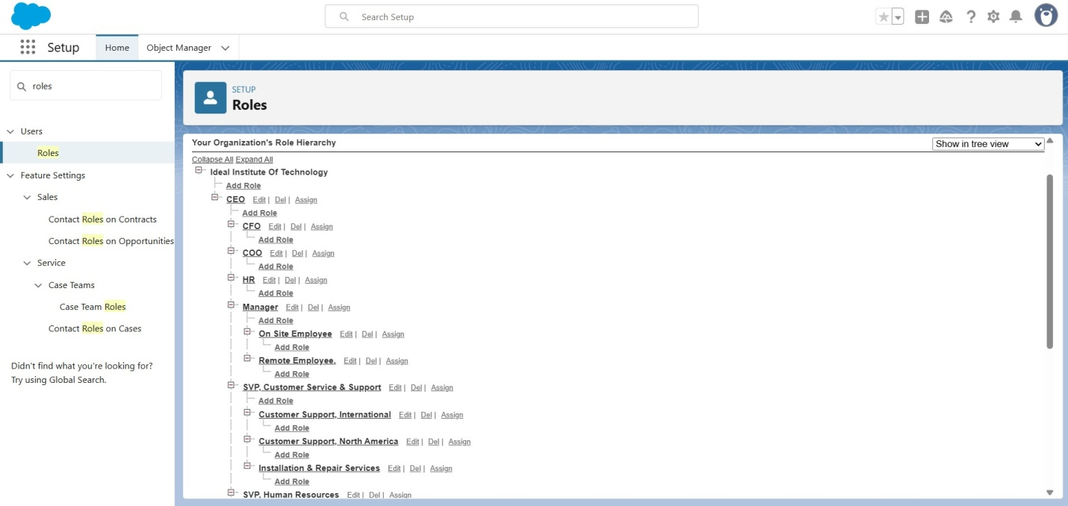

Creating HR Role, Manager, On Site Employee, Remote Employee. F. Users:
Creating users

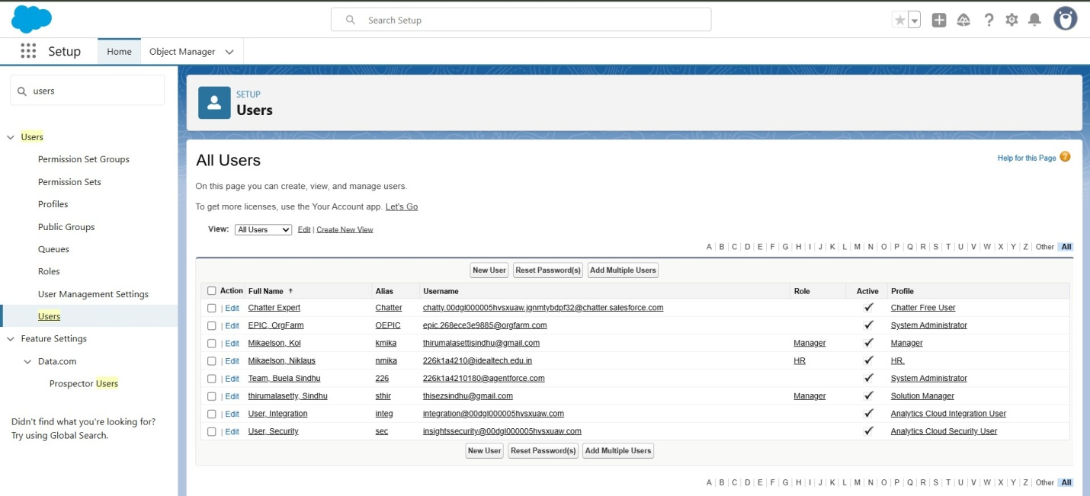
G.Approval process:

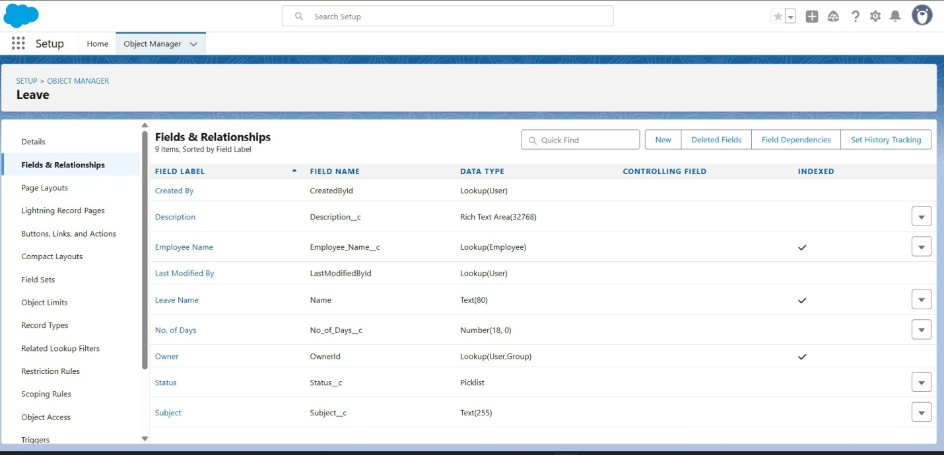

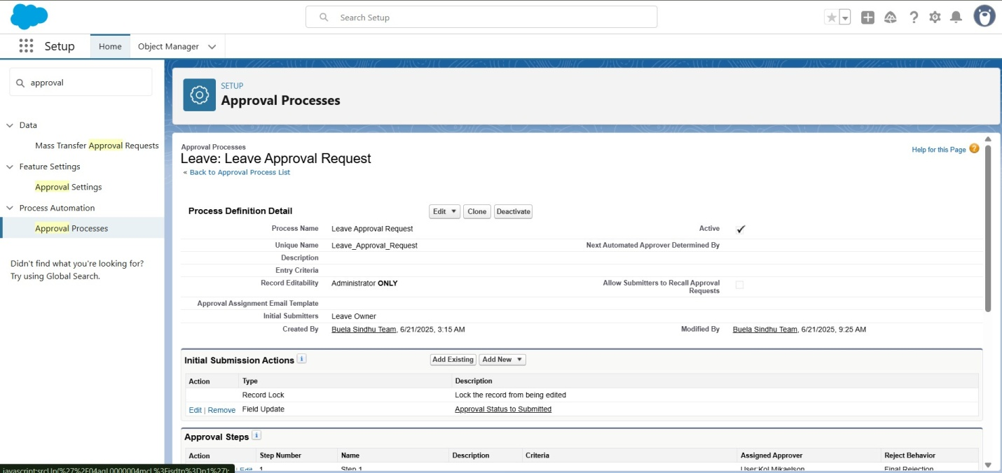

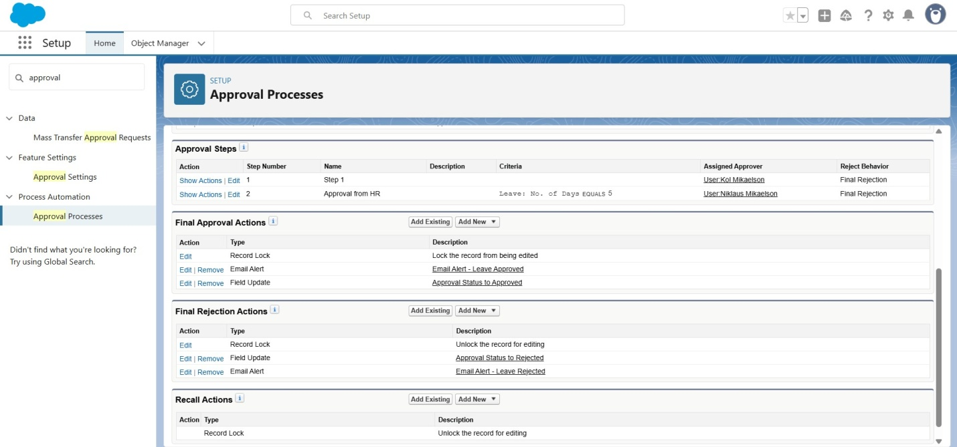

H. Apex Trigger: EmpInsert.apxt
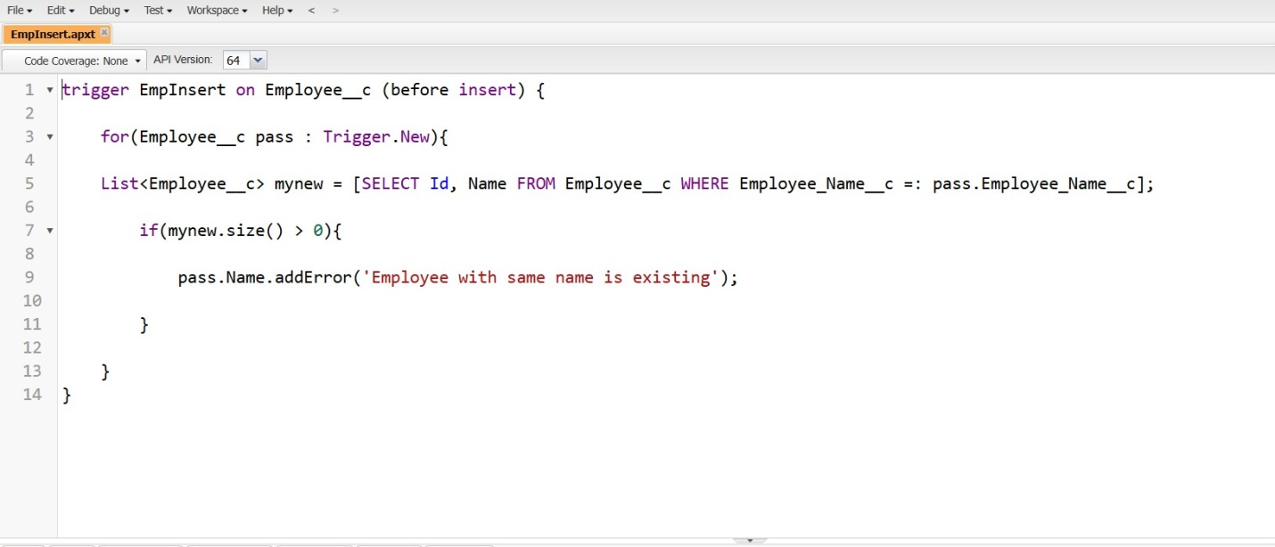

I.Testing the Trigger:For Activity 1 and try to create a record with the existing Employee Name say “Jackie Chan

